Create an employee table having the column names emp_id, name, age, marital status, address

1. The data present in emp_id column should be unique and the user should not be able to insert null values into emp_id column and name column as well.
2. Values of Emp_id must be incremented automatically when values are inserted into it.
3. Whenever d data for the age column is inserted ,the MySQL database should check whether the data inserted is > 18 or not. If the age is <18 data should not be inserted.
4. If marital status is not inserted then the data ‘no’ should be inserted by default.
5. Write a query to create a table **'electricity_connection_type'**.
6. Write a query to create a table **'slab'**.
7. Write a query to create a table **'building_type'**.
8. Write a query to create a table **'building'**.
9. Write a query to alter the Column **'owner_name'**to **'building_owner_name'**in the table **'building'**.
10. Write a query to change the datatype of the column **address** in the table **'building'** to varchar(255).
11. Write a query to create a constraint which allows only **'commercial'** or **'home'**connection_name in the **'electricity_connection_type'** table. Specify constraint name as **'check_connection_name'.**

alter table electricity_connection_type

add constraint check_connection_name check(connection_name in('commercial','home'))

1. Write a query to rename table **'building'**to**'building_details'.**
2. Write a query to drop table **'slab'**.
3. Write a query to drop table '**building_details**'.

NOTE:

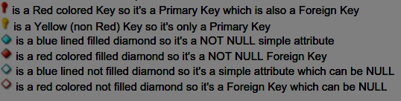

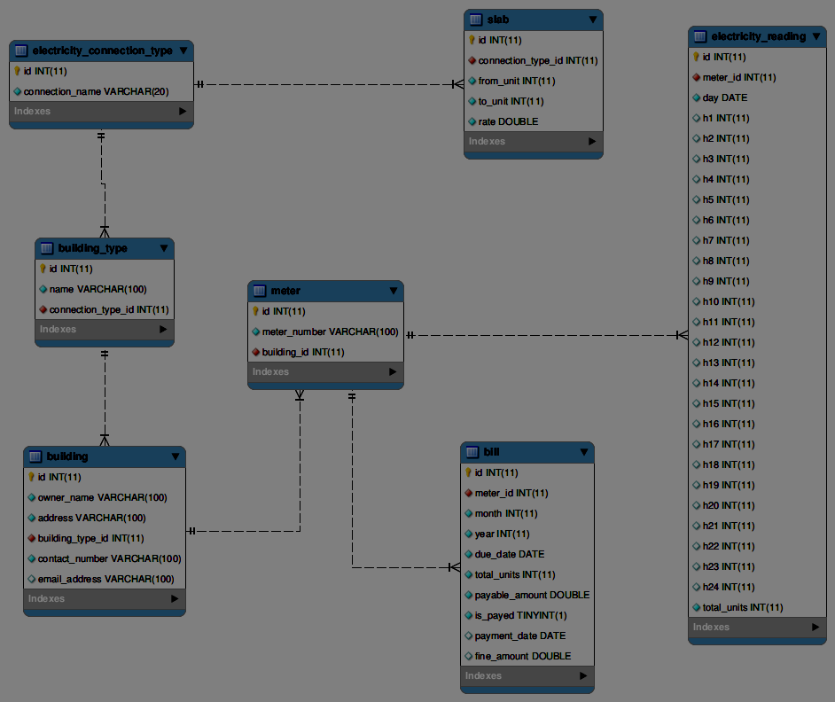

**Refer the schema diagram (metro train) and solve the following questions**

1. Write a query to create a table route.
2. Write a query to create a table station.
3. Write a query to alter the column 'locality' to 'station_locality' in the table station.
4. Write a query to rename table 'station' to 'station_details'.
5. Write a query to drop table station_details.

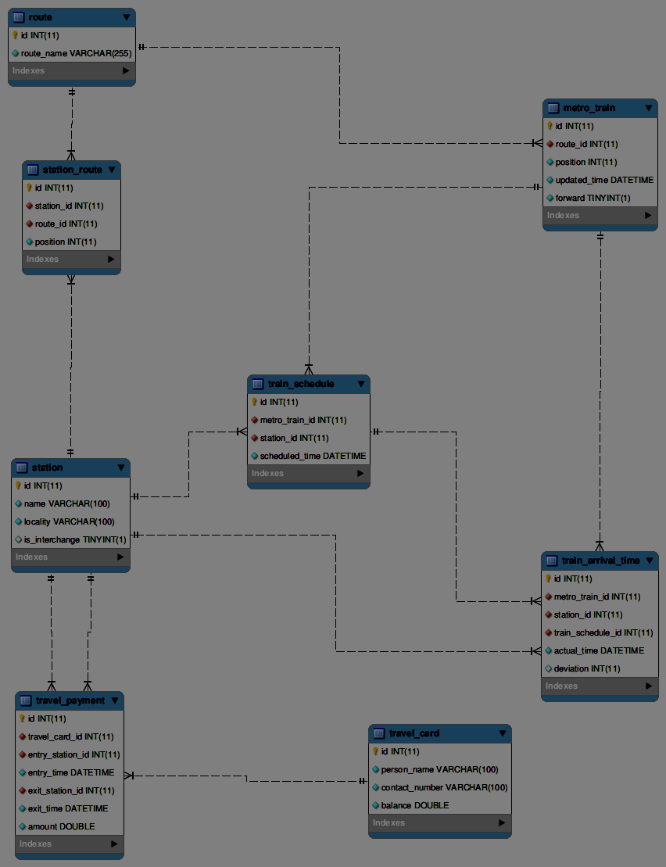

BANK

1. WAQ to display the branch_id, loan_amount by increasing loan_amount by 1000.
2. WAQ to display the account_number,transaction_amount by decrementing by 100.
3. WAQ to display opening_balance by increasing it by 1%.
4. WAQ to display the transaction_type where transaction_amount is equal to 2000.
5. WAQ to display loan_amount,branch_id where loan_amount is lesser than 500000.
6. WAQ to display branch_city whose branch_name is JASOLA.
7. WAQ to display first_name whose customer_city is either Delhi or Kolkata.
8. WAQ to display last_name whose occupation is either Student or Teacher.
9. WAQ to display account_number whose medium_of_transaction is CHEQUE and CASH.
10. WAQ to display customer_number whose occupation is SERVICE and STUDENT.

METRO

1. WAQ to display station_id,id and incrementing id by 1.
2. WAQ to display Entry_station_id amount by hiking it 10%.
3. WAQ to display travel_card_id,amount,incrementing amount by 10.
4. WAQ to display route_name whose ID is greater than 1.
5. WAQ to display travel_card_id whose amount is lesser than or equal to 20.
6. WAQ to display name whose is_interchange is not equal to 0.
7. WAQ to display station_id whose position is 1 either 2.
8. WAQ to display id whose forward is 1 either 2.
9. WAQ to display route_id whose position is 1 and 2.
10. WAQ to display route_id whose id is 1001 and 1005.

**Electricity_bill**

1. Write a query to display the entire contents of the 'electricity_connection_type'.Display the records in ascending order based on their connection name.
2. Write a query to display the entire contents of the building_type table, sorted by name in ascending order.
3. Write a query to display the entire contents of the 'building'.Display the records in ascending order based on owner name.
4. Write a query to display the entire contents of the  'electricity_reading', Display the records in descending order based on 'total_units'.
5. Write a query to display the owner_name and contact_number of all building, Display the records in ascending order based on owner_name.
6. Write a query to display the total_units, payable_amount, fine_amount of all bills , sorted by total_units in descending order.
7. Write a query to display the entire contents of the slab table, sorted by from_unit in ascending order.
8. Write a query to display the details of all the bills whose 'total_units' greater than 10000, sorted by total_units in descending order.
9. Write a query to display the details of all the bills with the due_date on '2017-10-01', sorted by payable_amount in descending order.
10. Write a query to display all the details of all the bills whose payment_date is on the year 2018, sorted by payable_amount in descending order.
11. Write a query to display the owner_name, address and contact_number of the buildings which does not have an email_address, sorted by owner_name in ascending order.
12. Write a query to display the entire details of the building whose building_type_id is 2, sorted by owner_name in ascending order.
13. Write a query to display the details of the electricity_reading whose total_units per day is between 500 and 1000, sorted by total_units in ascending order.
14. Write a query to display the details of the bill whose payment is not completed, sorted by due_date in ascending order.
15. Write a query to display the meter_id and total_units of electricity_reading whose 13th hour reading is lesser than the 14th hour reading, sorted by total_units in descending order.

**Metro_train**

1. Write a query to display all the details of the station which does not have any interchanges in ascending order based on name.
2. Write a query to display all the details of the station whose name starts with the letter 'K' in ascending order based on name.
3. Write a query to display the details of the travel_payment whose amount is greater than 30 in ascending order based on entry_time.
4. Write a query to display the details of the train_arrival_time which does not have any deviation in ascending order based on metro_train_id.
5. WAQ to display the route_name that starts with ‘D’
6. WAQ to display the name that ends with ‘N’
7. WAQ to display name where second character is ‘O’

**BANK**

1. WAQ to display first_name starts with ‘R’
2. WAQ to display branch_name that has a substring ‘MAIN’
3. WAQ to display last_name whose third character is ‘R’
4. WAQ to display the branch name that ends with ‘M’
5. Write a query to display the due date and  payable amount  of all the payment dates that are all not fall in between '**2017-09-10**' to '**2017-10-10**'.
6. Write a query to display the name of all building types that ends with letter 'L'. Display the record in ascending order based on building type name.
7. Write a query to display all the details of the buildings whose owner name contains 'di' in it. Display the records sorted in ascending order based on the owner name of the building.
8. WAQ to display the substring of the string ‘Tendulkar’ from 2nd position extract 5 characters.
9. WAq to display the substring ‘oha’ from the string ‘RajaRamMohanRoy’.
10. Display owner name and also display first character of owner_name.
11. WAQ to display the position of character ‘a’ in all the owner_name.
12. WAQ to display the substring ‘mad’ from owner_name where owner_name is ‘muhammad hafaz’(use both substring and instr)

**METRO**

1. Write a query to display the first 3 characters in each station. Give an alias name for the station name as '**station_code**'.Display the records sorted by station_code in descending order.
2. Write a query to display the**station name** in a 25 character length field by right padding with**'#'.** Give an alias name for the station name as **'modified_station_name'.**Display the records sorted in ascending order based on **station name**.
3. Write a query to display all person names. If the person name contains the letter 'A'(case sensitive) in it, then substitute the letter '**a**' with '**\*'**. Give an alias name for the person names as '**modified_name**'. Display the records sorted by person name in ascending order.  
   (Eg : If the person name is 'Madan', then replace the letter 'a' with '*' , so the result is M*d*n).
4. WAQ to display Only even Records From A building table.
5. WAQ to Round(1234.356,1)
6. WAQ to Truncate(1234.356,1)
7. WAQTD the no.of months from your DOB till date.
8. WAQTD the no.of years from your DOB till date.
9. WAQTD the no.of days from your DOB till date.

**BANK**

1. Write a query to display the customer number , firstname, customer’s date of birth . Display the records sorted in ascending order of date of birth year and within that sort by first name in ascending order.

## Write a query to display customer’s number, first name and middle name. For the customers who don’t have middle name, display their last name as middle name. Give the alias name as Middle_Name. Display the records sorted in ascending order based on customer number.

**MOVIE**

1. Write a query to display id,name,age,contact no of customers whose age is greater than 25 and who have registered in the year 2012. Display contact no in the below format +91- XXX-XXX-XXXX example +91-987-678-3434 and use the alias name as "CONTACT_ISD". If the contact no is null then display as 'N/A' Sort all the records in ascending order based on age and then by name.
2. Write a query to display id,name,age,contact no of customers whose age is greater than 18 and who have registered in the year 2013. Display contact no in the below format +91- XXX-XXX-XXXX example +91-987-678-3434 and use the alias name as "CONTACT_ISD". If the contact no is null then display as 'N/A' Sort all the records in ascending order based on age and then by name.

**ELECTRICITY BILL**

1. Write a query to display the average 8th hour unit consumption from electricity reading for all users.Give an alias name to the average 8th hour consumption as 'average_8th_hour_consumption'.
2. Write a query to display the average unit of electricity  consumption for all the users.Give an alias name to the average units as 'average_units_of_electricity'.
3. Write a query to display the average payable amount from bill wherepayable_amount is greater than 10000.Give an alias name to the average payable amount as 'average_payable_amount'.
4. Write a query to display the sum of payable amount from bill.Give an alias name to the sum of payable amount as 'sum_payable_amount'.
5. Write a query to display the sum of 12th hour unit consumption from electricity reading for all users.Give an alias name to the sum of 12th hour consumption as 'sum_12th_hour_consumption'.
6. Write a query to display the sum of payable amount with due date '2017-10-01'.Give an alias name to the sum of payable amount as 'sum_payable_amount'.
7. Write a query to display the minimum total units consumed by all users from electricity reading table. Give an alias name to the minimum total units as 'min_total_units'.
8. Write a query to display the minimum fine amount,paid by the user.Give an alias name to the minimum fine amount as 'min_fine_amount'.
9. Write a query to display the total payable amount, whose payment date is on the year 2018.Give an alias name to the total payable amount as 'sum_payable_amount'.
10. Write a query to display the maximum payable amount paid by the owners .Give an alias name to the maximum payable amount  as 'max_payable_amount'.
11. Write a query to display the number of bills having fine amount.Give an alias name as 'count_of_bills_with_fine'.
12. Write a query to display the number of bills  paid on '2017-09-23'.Give an alias name as bill_count.

**METRO TRAIN**

1. Write a query to display the number of users having balance less than 45.Give an alias name as min_balance_count.
2. Write a query to display the number of users having balance equal or more than 45.Give an alias name as max_balance_count.
3. Write a query to display all the travel card details those who having the balance more than 45.Display the records in descending order based onbalance
4. Write a query to display the total payment received from all the users. Give an alias name as total_payment.

select sum(amount) total_payment

from travel_payment;

1. Write a query to display the number of trains arrived on the date 21-Dec-2017. Give an alias name as total_trains.
2. Write a query to display the travel_card_id,entry_station_id and total amount recieved between the date 21-Dec-2017 to 23-Dec-2017. Give an alias name as total_payment.Display the records in ascending order based on their travel_card_id.

**BANK**

1. Write a query to display the number of customer’s from Delhi. Give the count an alias name of Cust_Count.